ROCA • Onboarding Design Reference | Document Version 1.0 • Status: Ready for Development

New Member Onboarding
Mockup Screen Reference
Step 1: Account Creation • Step 2: Organization Discovery
This document provides a detailed written description of the ROCA New Member Onboarding mockup screens for Steps 1 and 2 of the 7-step onboarding wizard. It serves as a reference companion to the visual mockup image, documenting the purpose, layout, and interaction design of each panel for the benefit of engineers, QA, and stakeholders.

1. Onboarding Screens Mockup
The mockup below renders the two entry screens of the ROCA onboarding wizard side by side, as they appear on a desktop web browser. The left panel covers Step 1 (Account Creation) and the right panel covers Step 2 (Organization Discovery). Both screens share a consistent header, liturgical season banner, and 7-step progress indicator.
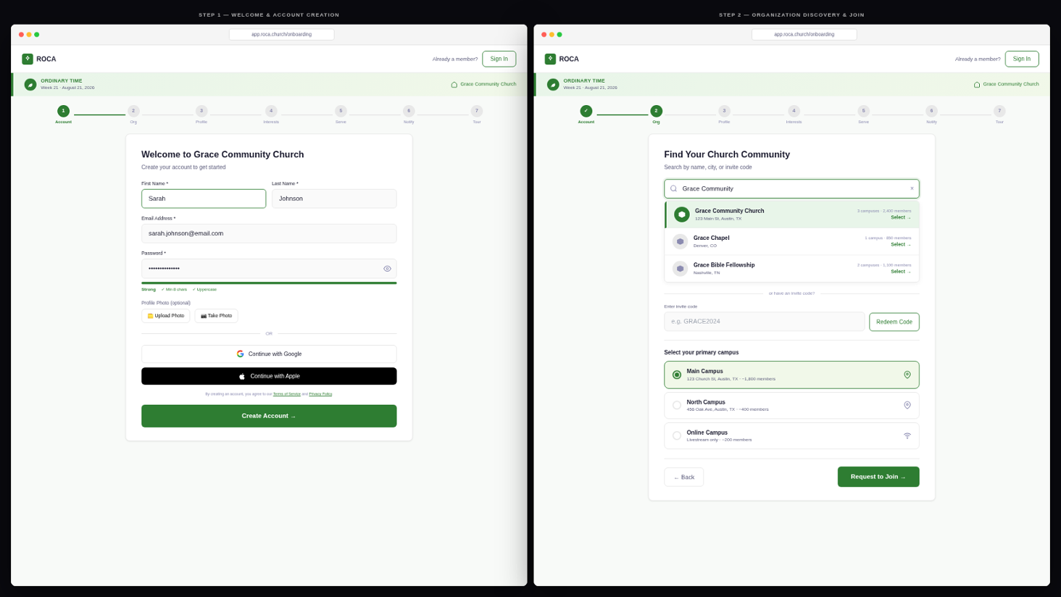
Figure 1 — ROCA New Member Onboarding: Step 1 (Account Creation, left) and Step 2 (Organization Discovery, right)

2. Left Panel — Step 1: Account Creation
Step 1 is the first screen a prospective member encounters when opening ROCA for the first time. Its primary goal is to minimize friction while establishing a warm, community-first tone. The form collects the minimum information required to create an account, and social auth options are prominently offered to reduce sign-up abandonment.

2.1 Purpose & Goals
- Primary action: Create a new ROCA account using email/password or social authentication.
- Tone: Welcoming and church-appropriate — "Welcome to Grace Community Church" rather than a generic SaaS sign-up headline.
- Progressive disclosure: Only the minimum required fields (name, email, password) are mandatory. Profile photo is optional and deferred.
- Social auth path: Google and Apple Sign-In are offered below the form to serve members who prefer a one-tap sign-up experience.

2.2 Screen Layout
The screen is centered on a lightly tinted background that reflects the current liturgical season color (Ordinary Time green in the mockup). A 680px max-width card contains all content. The ROCA wordmark appears in the top-left of the global header, with a "Already a member? Sign In" link anchored to the top-right.
Zone | Content Description
Global Header | ROCA wordmark (left) | "Already a member? Sign In" text link (right)
Liturgical Banner | Full-width green banner: "Ordinary Time • Week 21" with small leaf icon. Background tint matches the active liturgical season palette.
Progress Indicator | 7-step pill progress bar pinned to the top of the card. Step 1 is highlighted in dark green; Steps 2–7 are rendered as grey unfilled pills. Steps 2+ show step numbers only.
Headline Block | Two-line heading: "Welcome to Grace Community Church" (H1, dark green) / "Create your account to get started" (subtitle, muted green).
Name Row | Two equal-width text fields side by side: "First Name *" and "Last Name *". Both are required.
Email Field | "Email Address *" — single-row, full-width input. No placeholder in the filled state (shows typed value).
Password Field | "Password *" with a show/hide toggle icon. A password strength meter bar sits below it (green = strong), accompanied by hint text: "Min 8 chars, 1 uppercase".
Profile Photo | "Profile Photo (optional)" section with two action buttons: [Upload Photo] and [Take Photo] (mobile camera shortcut). Defaults to initials-based avatar if skipped.
Social Auth Divider | "---- OR ----" text divider followed by [Continue with Google] and [Continue with Apple] buttons. Social auth bypasses email/password fields; name and email are pre-populated from the OAuth profile.
Legal Microcopy | "By creating an account, you agree to our Terms of Service and Privacy Policy." — small gray text with hyperlinked terms.
CTA Button | [Create Account →] — full-width, forest green filled button. Disabled state until required fields are valid. Shows a loading spinner during API call.

2.3 Field Validation & Error States
- First Name / Last Name: required; minimum 1 character; max 100. Inline error shown on blur if empty.
- Email: required; must be a valid RFC 5321 address. API returns AUTH_004 if email already registered — inline error with "Sign In" link.
- Password: minimum 8 characters, at least 1 uppercase letter. Strength meter uses zxcvbn scoring (1-4 scale mapped to red/yellow/green).
- Profile photo: optional; accepted formats JPG, PNG, HEIC; max 10 MB. Client-side size/type validation before upload.
- CTA button remains disabled until First Name, Last Name, Email, and Password all pass validation.

2.4 Interactions & Navigation
- Successful account creation → JWT token pair stored → advance automatically to Step 2.
- Google / Apple sign-in → OAuth popup → on success, upsert member record → advance to Step 2.
- "Already a member? Sign In" link → navigate to /login, preserving any pre-filled invite context.
- If user arrived via an invitation link (/invite/{code}), org name is displayed in the header; Step 2 will be pre-filled.

2.5 Design Notes
Liturgical Theming
The screen background tint and banner color adapt automatically to the active liturgical season.
During Ordinary Time: deep green (#2D6A4F) banner, light green (#F0FFF4) tint.
During Advent: purple banner. During Easter: gold/white banner.
This establishes the ROCA spiritual personality from the very first interaction.

Invitation Context Preservation
When a member arrives via /invite/{code}, the invite code is stored in sessionStorage.
The Step 1 header shows the church name from the invite: "You've been invited to join Grace Community Church".
After account creation, the invite code is automatically redeemed in Step 2 (org pre-filled).
Expired or invalid codes display a non-blocking warning: "This invite has expired — you can still search for your church in Step 2."

3. Right Panel — Step 2: Organization Discovery
Step 2 connects the newly created account to a specific church organization and campus. It handles two entry paths: self-discovery search (user finds their church by name or city) and invitation code redemption (pre-filled from the invite link). The screen also surfaces campus selection, which personalizes the member's event feed from the moment onboarding completes.

3.1 Purpose & Goals
- Primary action: Associate the member's account with an organization and campus.
- Two entry paths: Search by name/city (self-discovery) or enter an invitation code (admin-invited).
- Campus selection: After selecting an org, the member picks their primary campus. This sets the default filter for all event and volunteer views.
- Approval gating: If the org requires admin approval, the member is placed in PENDING_APPROVAL status and sees the waiting screen. If open_registration is enabled, they are auto-approved and proceed immediately to Step 3.

3.2 Screen Layout
Step 2 reuses the same header, liturgical banner, and progress indicator as Step 1. The progress bar now shows Step 1 as a filled checkmark pill, and Step 2 as the active highlighted pill. The card content is organized vertically: search field, results list, invite code section, and (after org selection) campus picker and CTA.
Zone | Content Description
Progress Bar | Step 1 shows a green filled pill with a checkmark (✓). Step 2 is the active pill in dark green. Steps 3–7 remain as grey unfilled pills.
Headline | "Find Your Church Community" — H1 heading in dark green. Subtitle: "Search for your organization or use an invite code."
Search Field | Full-width text input with a magnifying glass icon on the left and a clear (x) button on the right. Debounced 300ms — fires GET /organizations?q= after each keystroke. Placeholder: "Search by church name or city..."
Search Results | Dropdown list appearing directly below the search field. Each result card shows: church name (bold), city/state (muted), campus count, member count, and a [Select →] action. Up to 5 results; "See more" link if > 5.
Invite Code Section | "---- OR have an invite code? ----" text divider, followed by an input field ("Enter invite code...") and a [Redeem Code] button. On successful validation, org and campus are pre-filled and the search field becomes read-only.
Campus Selector | Appears after an org is selected. Renders as a radio group listing all campuses for the org. Each campus card shows name, address, and an optional tag (e.g., "Online Campus"). The first campus is pre-selected by default.
Back / CTA Row | [<- Back] text link (navigates to Step 1) on the left. [Request to Join →] primary button on the right. Button label changes to [Join Now →] when the org has open registration enabled.

3.3 Organization Search Behavior
- Fires GET /organizations?q={query} with a 300ms debounce to avoid excessive API calls while the user types.
- Minimum 2 characters required before the first search fires. Below this threshold, a helper tip is shown: "Keep typing to search..."
- If no results are found, the dropdown shows: "Don't see your church? Ask your admin to send you an invite link."
- Results are ranked by: (1) exact name match, (2) city proximity (if geolocation permitted), (3) member count descending.
- Selecting an org from the dropdown immediately triggers campus loading via GET /campuses?org_id={id}.

3.4 Invite Code Redemption
Scenario | Error Code | User-Facing Message
Valid code | n/a | Org and campus pre-fill; search becomes read-only. Green success banner: "Invite code accepted for [Church Name]."
Code not found | INVITE_001 | Inline error: "This invite code was not found. Check for typos and try again."
Code expired | INVITE_002 | "This invitation has expired. Contact your church admin for a new link."
Max uses reached | INVITE_003 | "This invite code has already been used. Search for your church manually."

3.5 Campus Selection
- Campus cards are revealed immediately below the search results once an org is selected, with a smooth CSS transition.
- Each campus card displays: campus name, street address, city/state, and optional tags (e.g., "Online Campus", "Family-Friendly", "Accessible").
- Radio-button selection — only one campus may be selected as primary. The selected card receives a green highlighted border and filled radio dot.
- The selected campus_id is stored in the onboarding Zustand store and submitted alongside the join request.
- Members can change their primary campus at any time from Settings > Profile after onboarding.

3.6 Join Request Logic & Approval Paths
After the member selects an org, campus, and clicks the CTA, the system determines the appropriate approval path and routes accordingly:
Path A: Auto-Approved (open_registration = true OR valid invite code)
1. POST /organizations/{id}/join is called with member_id, campus_id, and optional invite_code.
2. System sets member.onboarding_status = APPROVED immediately.
3. Wizard advances to Step 3 (Profile Completion) without interruption.
4. Admin receives a non-blocking summary notification: "New member joined: [Name]."

Path B: Pending Admin Approval (org requires manual review)
1. POST /organizations/{id}/join creates a join request with status = PENDING_APPROVAL.
2. All org admins and pastors receive a push + email notification: "New member request from [Name]."
3. Member is redirected to the Pending Approval screen (Step 2.5), which shows public events while they wait.
4. When an admin approves from the admin dashboard (PUT /admin/join-requests/{id}), the member receives a push + email notification with a deep link to resume onboarding at Step 3.
5. If the request is rejected, the member receives an email with the reason and is invited to contact the church admin.

3.7 Interactions & Navigation
- Back button → returns to Step 1; all Step 1 data is preserved in the Zustand store.
- Selecting a different org clears the campus selection and reloads campus options for the new org.
- If the user closes the browser after completing Step 1 but before Step 2, they resume at Step 2 on next login (onboarding_step = 1 persisted in DB).
- On mobile, the keyboard dismisses when the user taps a campus card (form input blur).

3.8 Design Notes
Dual-Path Design Philosophy
Step 2 is intentionally designed to feel familiar whether the user was invited by a friend (invite code path) or discovering the app independently (search path).
The invite code section is displayed below the search rather than above it, so self-discovery users are not distracted by a form field they don't need.
When an invite code is redeemed, the search field visually "locks" to prevent accidental switching, reducing cognitive load.

4. Shared UI Elements (Both Screens)

4.1 7-Step Progress Indicator
- Displayed as a horizontal row of 7 pill-shaped step indicators at the top of the wizard card.
- Completed steps: filled green pill with a white checkmark (✓) icon.
- Active step: filled dark green pill with white step number; slightly larger than inactive pills.
- Upcoming steps: outlined grey pills with step numbers.
- On mobile, step labels (text) are hidden; only numbers and icons are shown to conserve horizontal space.
- The indicator is non-interactive — users cannot click ahead to skip steps; they must use the wizard navigation buttons.

4.2 Liturgical Season Banner
- Displayed as a full-width colored strip between the global header and the card.
- Content: a small season icon, season name, and current week number (e.g., "Ordinary Time • Week 21").
- Color is driven by the active liturgical season: green for Ordinary Time, purple for Advent/Lent, gold for Christmas/Easter, red for Holy Week/Pentecost.
- This banner is identical to the one displayed throughout the main application, establishing visual continuity from first contact.

4.3 Mobile Adaptations
- Both screens stack to full-width single-column layouts on mobile viewports (< 768px).
- Navigation buttons (Back, Next/CTA) are pinned to the bottom of the viewport as a sticky action bar.
- The "First Name / Last Name" two-column row stacks vertically on mobile.
- The social auth buttons (Google, Apple) stack vertically on mobile.
- Campus selection cards expand to full width on mobile and increase tap target height for accessibility.

5. Step 1 → Step 2 Transition
The transition from Step 1 to Step 2 occurs immediately after the account creation API call succeeds and a JWT token pair is stored. The transition is a horizontal slide animation (250ms ease-in-out), with Step 1 sliding out to the left and Step 2 sliding in from the right. The progress indicator updates in sync with the slide. On mobile, this is a native-feeling pager swipe animation using the React Native Pager View library.
Trigger | System Action | User Feedback
Click [Create Account] | POST /auth/register; store JWT tokens; update member.onboarding_step = 2 | Loading spinner on CTA button; progress pill advances
OAuth flow completes | POST /auth/register/social; same token storage and step update | Modal closes; same slide transition
Arrive via invite link | Invite code validated; org/campus pre-populated in Step 2 state | Step 2 shows org already selected with green confirmation banner

6. Related Document References
Document | Reference Content
ROCA New Member Onboarding Design Document | Full onboarding user flow specification including all 7 steps, user stories (US-1 through US-10), implementation architecture, and testing strategy.
ROCA Unified Technical Design Specification | Complete application architecture, 15-table database schema, 75+ API endpoints, RBAC permission matrix, and infrastructure design.
ROCA Developer Handoff Document | Sprint plan, TypeScript type definitions, React component patterns, and copy-paste code snippets for engineering teams.
ROCA Kiro Spec (design.md + tasks.md) | Machine-readable Kiro spec files for import into the Kiro development workflow tool. Covers 39 implementation tasks across 6 sprints.

ROCA • New Member Onboarding Mockup Reference • Version 1.0 • Confidential

